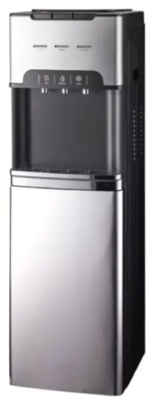

LG Dispenser
Rs. 212,000
An LG dispenser is a convenient kitchen appliance designed to store and dispense beverages, water, or other liquids with ease.

Specifications
- Model: DG100
- Type: Freestanding Dispenser
- Capacity: 446L – 760L+
- Compressor: Inverter Linear Compressor

Key Features
- Inverter Linear Compressor
- Hygiene Fresh+ Filter
- Touch Control Panel
- Multi Air Flow Cooling

